Frequent fire in California chaparral reduces post-fire shrub regeneration and native plant diversity

Ashley R. Grupenhoff1* & Hugh D. Safford1,2

1Department of Environmental Science and Police, University of California, 1 Shields Ave, Davis, California 95616, USA

2Vibrant Planet, Incline Village, Nevada, USA

*Correspondence to:

Ashley Grupenhoff

Ph.D. candidate

323 1st St.

Davis, CA 95616

Tel: +1-571-230-9627

e-mail: [agrupenhoff@ucdavis.edu](mailto:agrupenhoff@ucdavis.edu)

# Abstract

Fire is crucial for maintaining species diversity and resilience in fire-adapted shrublands of the world’s Mediterranean climate zones (MCZs), which include the chaparral shrublands of the North American MCZ. Chaparral is adapted to high intensity burning, with long intervals between fires (30-100 years) typical under undegraded conditions. In much of the range of chaparral, modern fire frequencies are much higher however, driven largely by high densities of human ignitions and coincidence between ignitions and severe weather conditions. This change in fire regime has major implications for biodiversity, leading to exotic invasion, decreased ecosystem services, and potential type conversion of shrubland to grassland dominated by exotic species. We studied the impact of increased fire frequencies on the composition and abundance of herbaceous and woody species in the Interior Coast Range of northern California. Our study area is one of the most frequently burned areas in California, which afforded us the opportunity to investigate higher fire frequencies than heretofore reported in the scientific literature for California. We surveyed fifty-four 250-m2 plots to assess changes in plant community composition and postfire regeneration of chaparral shrubs across a wide range of fire frequencies, including plots that have burned up to six times in the past 30 years. Our findings reveal that three short-interval fires significantly reduced post-fire native woody regeneration, with obligate seeding species experiencing a 99% reduction and facultative species showing an 83% reduction in regeneration in the most frequently burned plots. Moreover, the overall marginal effect of one additional short interval fire decreased the proportion of native species cover by 12% and both richness and Shannon diversity by 4%. Consequently, areas with higher fire recurrence exhibited a more homogeneous landscape, dominated by a similar group of non-native species.

***Keywords:*** *chaparral, fire frequency, post-fire regeneration, species diversity*

# Introduction

Fire is vital for maintaining biodiversity in many fire-adapted ecosystems around the world, but interactions between anthropogenic drivers such as rapid climate warming, disturbance regime interventions, and land use change are causing major changes in the spatial-temporal pattern of fire (hereafter, fire regime) [(UNEP 2022)](https://www.zotero.org/google-docs/?wlUU6w). In the North American Mediterranean Climate Zone (NAMCZ), the climate is warming and becoming seasonally drier and more variable, droughts and episodes of extreme fire weather are more common, and there is an increase in urbanization and human populations [(Keeley and Fotheringham 2001; Abatzoglou and Williams 2016; Molinari et al. 2018; Syphard et al. 2018)](https://www.zotero.org/google-docs/?mYqqHr). Changes in climate and increased housing densities have altered natural fire regimes across the region, posing serious risks to the NAMCZ, especially chaparral shrublands[(Molinari et al. 2018; Park et al. 2018; Syphard et al. 2019)](https://www.zotero.org/google-docs/?bsC1ug).

Chaparral shrublands are a widespread vegetation type in the NAMCZ that provides numerous ecosystem services and is an important biodiversity hotspot [(Rundel 2018; Underwood et al. 2018)](https://www.zotero.org/google-docs/?U2Yrgv). The chaparral shrub canopy is characteristically dense and vertically and horizontally continuous without a gap between surface and canopy fuels, and as a result fires in chaparral typically burn at high intensities [(Keeley and Safford 2016)](https://www.zotero.org/google-docs/?llwLbF). Chaparral is also adapted to relatively infrequent fire, with paleo- and historical data and modeling studies suggesting an optimal fire return interval range between c. 30 and 90 years [(Van de Water and Safford 2011)](https://www.zotero.org/google-docs/?BXB4uo). Although chaparral is relatively resilient to episodic variability in fire frequencies (CITE), long-term and profound alteration of the natural fire regime can lead to transitions from chaparral to woodland or grassland.For example, very long intervals without fire can promote tree invasion and transitions to woodland or forest [(Callaway and Davis 1993; Safford et al. 2021)](https://www.zotero.org/google-docs/?pOrqHY). Much more common today is a transition to grassland dominated by non-native species driven by an increase in fire frequency [(Zedler et al. 1983; Keeley and Fotheringham 2001; Syphard et al. 2019)](https://www.zotero.org/google-docs/?98G5j1). In southern California, studies show that large areas of lowland and lower montane chaparral have been converted to exotic grassland in recent decades, driven primarily by an interaction between recurrent drought and short-interval reburning [(D’Antonio and Vitousek 1992; Keeley and Brennan 2012; Park et al. 2018; Syphard et al. 2019)](https://www.zotero.org/google-docs/?JDBGoV).

Uncharacteristically frequent fire can eliminate chaparral species without adaptations to short fire return intervals. Many plants adapted to fire-prone ecosystems have traits that allow them to survive and regrow after fire or to rapidly recolonize burned areas [(He et al. 2019)](https://www.zotero.org/google-docs/?QjkoP7). Postfire recovery includes factors such as regrowth, reproduction, dispersal, germination, and establishment, all of which are mediated by how plant traits interact with fire severity [(McLauchlan et al. 2020)](https://www.zotero.org/google-docs/?N2ClE7). In chaparral, postfire recovery involves regeneration initiated by germination of the dormant seed bank, resprouting from lignotubers and other vegetative structures, or wind dispersal. Native woody species are commonly divided into obligate seeders (species incapable of vegetative regeneration and which germinate from the dormant seed bank in the first or second postfire year), obligate resprouters (which lack a dormant seed bank but regenerate vegetatively), and facultative seeders (which have post-fire germination coupled with resprouting) (Keley and Safford 2016). Increased fire frequency may induce substantial mortality for obligate seeders since these species often require a decade or more to replenish the seed bank [(Zedler et al. 1983; Jacobsen et al. 2004)](https://www.zotero.org/google-docs/?rKFxz3). Studies have shown that even resprouting chaparral species may be eliminated if fire is frequent enough [(Haidinger and Keeley 1993; Keeley and Brennan 2012)](https://www.zotero.org/google-docs/?eQ8atl).

Shifts in species composition and type conversion to nonnative grassland have large-scale implications for ecosystem resilience, regional and local biodiversity, and ecosystem services such as primary production, carbon sequestration, nutrient cycling, pollination, erosion mitigation, and habitat provision [(Rundel 2018; Underwood et al. 2018)](https://www.zotero.org/google-docs/?H6Qr5y). As such, understanding the nuanced effects of fire recurrence on biodiversity and recovery is necessary for understanding the extent and future trajectories of chaparral type conversion. To date, no study has examined these effects at sites that have burned more than three times in the past few decades. Additionally, only a handful of studies have focused on the Coast Range of northern California, which is becoming one of the most frequently burned regions in the state.

Our study took place in the footprint of the 2020 Hennessy Fire, the largest of the fires comprising the LNU Lightning Complex. The landscape burned by the Hennessy had a rich fire history: 38% of the Hennessy Fire had burned in the previous 10 years, the highest proportion of any 2020 fire, and more than 50% had burned at least once in the previous 20 years [(Safford et al. 2022)](https://www.zotero.org/google-docs/?R7C3pE). Some areas in the Putah and Cache Creek drainages had burned six times since 1985, and up to four times in the previous seven years, which makes these areas among the most frequently burned wildlands in all of California. This provides a unique research opportunity, as to this point, no published studies in California have evaluated the impacts of more than three fires on chaparral resilience.

To better understand when chaparral communities lose resilience to invasion, we asked two primary questions: 1) How does fire frequency affect the diversity and cover of native and non-native species; and 2) What are the consequences of higher burn frequency on shrub seedling establishment and resprouting success? Based on results from previous studies, we hypothesized (1) a reduction in species diversity and local richness in areas with more than 2 short interval fires and (2) decreased native shrub regeneration and resprout growth of native shrubs. Specifically, we hypothesized higher burn frequency would lead to a reduction in the probability of obligate and facultative seedling regeneration after 2 short interval fires (2a) and a reduction in resprout growth of facultative species after 3 short interval fires (2b).

# Methods

***Study Site:***

The study was conducted in the Interior Coast Range of northern California which supports a diverse mosaic of chaparral, oak woodland, and grassland. Intact chaparral vegetation is dominated by drought-tolerant, sclerophyllous shrubs. Our study focused on *Adenostoma fasciculatum* (chamise) chaparral and mixed chaparral stands. Nearly pure stands of chamise-dominated chaparral occur on sandstone substrates on xeric exposures with shallow soils, while mixed chaparral stands occur on more mesic exposures with deeper soils and include chamise as well as other co-dominant species such as *Ceanothus* spp.*, Heteromeles arbutifolia, Arctostaphylos* spp., and *Quercus berberidifolia* (add

Historic mean fire-return intervals in California chaparral have been estimated between 30-90 years [(Van de Water and Safford 2011)](https://www.zotero.org/google-docs/?mu2cFS) and the ignition sources prior to European colonization were primarily Indigenous peoples who burned in grasslands and chaparral for foods, medicines, and ceremonial items [(Anderson and Keeley 2018)](https://www.zotero.org/google-docs/?GuADC5); lightning ignitions certainly occurred but were relatively rare, as they are today [(van Wagtendonk and Cayan 2008)](https://www.zotero.org/google-docs/?bGzkNG). Today, human ignition sources are typically due to accidents from power lines, vehicles, and campfires [(Syphard and Keeley 2015; Anderson and Keeley 2018)](https://www.zotero.org/google-docs/?lQOdfn).

We sampled post-fire chaparral plant communities after the 2020 LNU Lightning Complex Fire, which was one of the largest fires in California history, burning 124,000 hectares in Napa, Yolo, Solano, and Lake Counties [(Safford et al. 2022)](https://www.zotero.org/google-docs/?ILEETV). We focused on the area burned in the Hennessy Fire, which ignited by lightning on August 17th and was extinguished in early October. In total, 54 plots were sampled at Quail Ridge UC Natural Reserve (38°30’ N, 122°08’ W), Cold Canyon UC Natural Reserve (38°30’ N, 122°06’ W), Cache Creek Regional Park (38°54’ N, 122°18’ W), and Bobcat Ranch Audubon Reserve (38°31’ N, 122°04’ W) (Fig. 1). All sites are between 260-540 m elevation and occur on inceptisols (mostly Maymen and Millsholm soil series) on sandstone substrates (California Soil Web; <https://casoilresource.lawr.ucdavis.edu/gmap/>). The study area experiences a Mediterranean climate with an annual average of 630-760 mm precipitation, mean January minimum and maximum temperatures are 3°C and 14°C, respectively, and mean July minimum and maximum temperatures are 15°C and 34°C (30-year average, 800-m resolution, PRISM Climate Group 2022).

The study area has a variable fire history, ranging from never burned to six prior burns in the past 30 years (Table 1). Plot locations were stratified across a fire frequency gradient and aspect, with an equal number of plots on cool (N and E aspects) and warm (S and W aspects) slopes.GIS layers from the USDA Forest Service were used to extract the start date and fire size for fires that occurred during the past 30 years. Fire frequency was calculated using the California Fire Return Interval Departure (FRID) database [(Safford et al. 2011)](https://www.zotero.org/google-docs/?sQsESE). Since these fire perimeters generally ignore unburned patches within fires that are less than hundreds of acres in size, we used Google Earth historical imagery to examine the landscape for unburned patches after each fire and we adjusted the FRID database fire frequencies accordingly. Heat load index was calculated for each transect using aspect and slope to account for the amount of solar radiation received [(McCune and Keon 2002)](https://www.zotero.org/google-docs/?JiDU7o). Precipitation and temperature point estimates were extracted for each transect using the 4 km resolution PRISM dataset (PRISM Climate Group 2022).

***Sampling Design & Processing:***

At each of the 54 plots, 50 x 5-m belt transects were established following [Safford and Harrison (2004) and Werner et al. (2022)](https://www.zotero.org/google-docs/?XIUlpK). Sites were visited in the spring of 2021 and 2022. All plant species were recorded within the entire 250-m2 transect to measure the overall richness of native and exotic plant species. Five 1-m2 quadrats were sampled at 10-m intervals along the transect line, measuring: the percent cover of all native and exotic species; number and height of shrub seedlings; resprout height; percent cover of rock, bare soil, and litter; and litter depth. All variables collected at the 1-m2 scale were averaged to give a transect-level value. Plant life history data for each species were obtained from the USDA Forest Service Fire Effects Information System or the University of California Jepson Herbarium. Species were classified by origin (native, non-native), lifeform (tree, shrub, forb, graminoid, fern), and fire regeneration strategy (obligate seeder (OS), facultative seeder (FS), obligate resprouter (OR)). The proportion of native species cover, species richness, and diversity were calculated at each transect each year (2021 & 2022). We calculated the proportion of native plant cover in each plot as the total native cover/(total native cover + total exotic cover). Additionally, we calculated the proportion of local species richness (calculated as the mean number of species per 250 m2 plot) and the proportion of Shannon-Wiener diversity (which gives weight to rare species) using the vegan package in R [(R Core Team 2021; Oksanen et al. 2023)](https://www.zotero.org/google-docs/?yJXYTf).

Fire severity was estimated in each belt transect by measuring the stem diameter (1 cm from the terminus) of four stems from a randomly chosen *Adenostoma fasciculatum* (chamise) individual rooted in or adjacent to each quadrat [(Perez and Moreno 1998)](https://www.zotero.org/google-docs/?5NqRgS). Additionally, five more individuals were measured at the entire 250m2 transect scale. In the few cases when chamise was not present we used *Heteromeles arbutifolia* or *Quercus berberidifolia* individuals. We measured heterogeneity in fire severity within each belt transect by calculating the coefficient of variation for the five quadrats within a transect.

***Statistical analyses***

*Species cover, diversity, and composition (H1)*

Bayesian generalized linear mixed models were used to investigate the interaction between fire frequency on the proportion of native species cover, richness, and diversity for both survey years using a Beta Binomial likelihood (Equation 1), which accommodates values between 0 and 1. To determine which environmental covariates to add to the model, we used the expected log pointwise predictive density (ELPD) to measure leave-one-out cross-validation for our goodness of fit measure. The covariates that we evaluated were fire frequency (numBurn), mean annual precipitation, mean annual temperature, heat load index, slope and aspect. We verified that independent variables were not highly correlated using the Spearman correlation coefficient (Supplemental Fig. 1). We first fit the proportion of native species cover with each individual predictor separately and added significant predictors in order of ELPD to determine whether they significantly increased ELPD of the resulting model. Non-metric multidimensional scaling (NMDS) was used to visualize compositional differences between areas with variable fire recurrence as a part of the vegan package in R [(R Core Team 2021; Oksanen et al. 2023)](https://www.zotero.org/google-docs/?WaFdDF). This ordination uses rank-order correlation and Bray-Curtis dissimilarities to model the differences among treatments based on species composition and abundance of all plant species.

*Equation 1:*

$$prop.nativecover_{i,j} \sim Beta(μ_{i,j },ϕ)$$

$$logit(μ_{i,j }) = α + β_{numBurn}numBurn +β_{numBurn}numBurn^{2} + β_{SurveyYear}SurveyYear$$

$$α \sim student_t(3, 0, 2.5)$$

*Shrub regeneration (H2a)*

We used a similar modeling procedure to understand how fire frequency influenced shrub regeneration and resprout growth. We fit seedling presence/absence using multiple Bayesian generalized linear models with Bernoulli likelihood (Equation 2). Like species diversity, we used the ELPD as a measure of leave-one-out cross-validation for our goodness of fit measure to compare. We first fit the presence/absence of a seedling with each individual predictor separately and added significant predictors in order of ELPD to determine whether they significantly increased ELPD of the resulting model. The covariates that we evaluated were fire frequency (numBurn), mean annual precipitation, mean annual temperature, heat load index, aspect, and slope. For seedling presence/absence, we calculated the area under the receiver operating curve (AUC) with the ROCR package in R, which is a commonly used method to evaluate model fit [(Sing et al. 2005)](https://www.zotero.org/google-docs/?ToEtm0). AUC values >0.8 indicate good model prediction while values near 0.5 indicate the model is not better than random chance. We created a separate model for facultative and obligate seeding species, and for each individual species separately.

*Equation 2:*

$$presence \sim Bernoulli(ρ_{i})$$

$$logit(ρ_{i}) = α +β_{numBurn}numBurn +β_{SurveyYear}SurveyYear$$

$$a \sim student_t(3, 0, 1)$$

$β$ ~ normal(0,1)

*Resprout growth (H2b)*

To test how the growth of resprouting *A. fasciculatum* was impacted by fire frequency, we fit resprout height one year after fire with a Gaussian distribution (Equation 3). After ELPD measure of leave-one-out cross validation model selection, the final model included covariates for heat load index and the diameter of the largest stem (an indicator of prefire size). Resprout growth was square root transformed to meet assumptions of normality.

*Equation 3:*

$$resprout growth \sim N(μ_{i},σ)$$

$$μ_{i}= α +β_{numBurn}numBurn +β_{hli}Heat load index +β_{diam largest stem}Diam largest stem$$

$$a \sim normal(0,1)$$

$β$ ~ normal(0,1)

All models were created using the brm function in the brms package [(Bürkner 2017)](https://www.zotero.org/google-docs/?2bTiqP) in R version 4.1.1 [(R Core Team 2021)](https://www.zotero.org/google-docs/?KGTIEu). Continuous independent variables were centered and scaled prior to analysis. We used mildly regularizing priors to prevent overfitting with 4 chains, each with 2000 iterations and a warmup of 1000. Trace plots and R-hat values were assessed to confirm proper mixing and model convergence.

# Results

*Fire severity*

Mean and maximum fire severity, as well as the heterogeneity of fire severity, were reduced with increased fire frequency (>2 in the past 30 years) (Fig. 2, Table 2). Fire severity, which is positively related to the diameter of the measured stem termini, was high in sites that only burned once before the Hennessy Fire, but low in all other fire frequency classes (differences among FF = 3, 4, 5, and 6 were not statistically significant from each other).

***Species cover, diversity, and composition (H1)***

In total, 223 species were found throughout the study area. As predicted, we found that the proportion of native species cover, the proportion of native richness, and the proportion of native Shannon diversity declined with increased fire recurrence in both survey years (Fig. 3). The effect of fire recurrence was strongest for the proportion of native cover (βnumburn = -1.17; CIs = -1.67 to -0.67) and moderately strong for the proportion of native species richness (βnumburn = -0.50; CIs = -0.86 to -0.15) and Shannon diversity (βnumburn = -0.65; CIs = -1.14 to -0.16) (Supplemental Table 1). The overall average marginal effect of a 1-unit increase in fire frequency decreased the proportion of native cover by 12%, native richness by 4%, and native Shannon diversity by 4%.

This effect of fire frequency, however, varied at higher and lower levels of fire frequency for all diversity metrics (Fig. 3). At lower levels of fire frequency, a one-unit increase in frequency led to a significant 16% decrease in the proportion of native cover (Fig. 3b). In contrast, a frequency of 5 fires in the past 30 years resulted in a slight 5% *increase* in the proportion of native cover. The pattern of native richness and Shannon diversity closely align with the findings for native cover. For lower levels of fire frequency, a one-unit increase is associated with a 7% and 9% decrease in native richness and Shannon diversity, respectively. However, as fire frequency rises to higher levels there is a slight shift to a 2% increase in native richness and a 1% increase in Shannon diversity.

Plots in areas with different fire frequencies had different species assemblages. The NMDS ordination of species composition resulted in an overlapping cluster of plots with higher fire recurrence (>2 short interval fires) that contain more non-native herbaceous species, while plots with lower fire recurrence (≤ 2 short interval fires) contained more native herbaceous species and shrubs (Fig. 4). Species characteristic of the high fire frequency plots included *Avena barbata*, *Centaurea melitensis,* *Erodium cicutarium*, and *Festuca myuros* (Fig. 4), all classic dominant species in the exotic annual grassland that characterizes highly disturbed sites in lowland California. Plots with higher fire recurrence had smaller clusters compared to areas with low fire recurrence, indicating a shift from a more heterogeneous post-fire landscape to a more homogeneous landscape with many similar non-native species. Species assemblages also became progressively more differentiated from the one-burn assemblage as fire frequency increased (Fig. 4).

***Shrub regeneration (H2a)***

Increased fire frequency in chamise chaparral reduced shrub seedling regeneration, as expected (Fig. 5). In plots with higher fire frequency (FF=6), seedling regeneration for FS declined by 83% and OS regeneration declined by 99% when compared to plots with lower fire frequency (FF=1). OS species, including *Ceanothus oliganthus* and *Ceanothus cuneatus,* were almost completely eliminated in areas with >2 fires in the past 30 years (Fig. 5). We found a strong negative association between fire frequency and the presence of OS regeneration (βnumburn = -0.92; CIs = -1.43 to -0.49; Fig. 5a) and a significant, albeit less strong, negative association between fire frequency and the presence of FS regeneration (βnumburn = -0.33; CIs = -0.47 to -0.19; Fig. 6a). Fire frequency significantly reduced the presence of *Ceanothus cuneatus* (βnumburn = -1.10; CIs = -1.65 to -0.64; Fig. 5b) and *Ceanothus oliganthus* (βnumburn = -1.20; CIs = -2.27 to -0.41; Fig. 5c). The effect of fire frequency on FS regeneration was species-specific and significantly reduced the presence of *Adenostoma fasciculatum* (βnumburn = -0.70; CIs = -1.02 to -0.40; Fig. 6b) and *Lepechinia calycina* seedlings(βnumburn = -0.66; CIs = -1.00 to -0.35; Fig. 6d). Despite an overall decrease in presence of FS regeneration due to fire frequency, we found a slight qualitative increase in *Eriodictyon californicum* seedlings(βnumburn = 0.05; CIs = -0.18 to 0.28) but this effect was not significant (Fig. 6c).

***Shrub resprout growth (H2b)***

In contrast to hypothesis 2b, we did not see any significant difference in *A. fasciculatum* resprout growth with increased fire frequency (βnumburn = 0.00; CIs = -0.02 to 0.01; Fig. 7). Despite a reduction in live individuals, postfire height was around 0.4 meters 1-year after fire for all levels of fire frequency. Heat load index and the diameter of the largest stem improved model fit, but did not have a strong association with resprout growth (βhli = 0.00; CIs = -0.02 to 0.01; βdiam largest stem = -0.01; CIs = -0.03 to 0.00)

# Discussion

Our results are consistent with other studies that show a reduction in native shrub regeneration and species diversity after multiple, short-interval fires in chaparral shrublands [(Zedler et al. 1983; Haidinger and Keeley 1993; Jacobsen et al. 2004; Keeley and Brennan 2012)](https://www.zotero.org/google-docs/?ZyAZho). Yet our study is the first to examine how such high fire frequencies – up to six times in the past 30 years – may be impacting chaparral vegetation in the NAMCZ. Our findings highlight how uncharacteristically high fire recurrence (>2 short interval fires in 30 years) in chaparral results in a reduction in native woody regeneration and homogenization of the plant community. We found that a diverse mix of native shrub and herb species are being replaced with a smaller, more homogeneous set of non-native annual species. Overall, these results highlight the complex relationship between fire frequency and diversity metrics, showcasing how different levels of fire frequency can impact native cover, richness, and Shannon diversity in varying ways.

It is important to note that the occurrence of short intervals between fires, rather than fire frequency per se, is a key component to type conversion [(Jacobsen et al. 2004; Syphard et al. 2019)](https://www.zotero.org/google-docs/?naOWqU). Our study examines the effect of fire frequency, and because short interval fires are more likely to occur when fire is more frequent, we cannot parse a partial causality between the two in this study. All of our sites that burned more than three times in the past 30 years were also the sites that had the shortest fire return intervals (between 2 and 5 years)**.** Short fire return intervals reduce fire intensity, promoting non-native species persistence and reducing regeneration of native chaparral shrubs (Keeley et al. 2006). This has especially negative consequences for obligate seeding shrubs that require 10-15 years to mature before replenishing the seed bank (Zedler et al. 1983; Jacobson et al. 2004), and in particular for the genus *Ceanothus*, which tends to germinate best under higher fire intensities that are only possible in the presence of a high woody fuel load that is characteristic of an infrequenlty burned site [(Moreno and Oechel 1991; Le Fer and Parker 2005)](https://www.zotero.org/google-docs/?sawClt). Despite our inability to parse the importance of fire return interval and fire frequency independently, assessing fire frequency by itself is still relevant given the increasingly common condition of frequent fire in chaparral and that the close linkage between the two variables.

***How does fire frequency affect the diversity and cover of native and non-native species?***

Our study confirms that increased fire frequency in chaparral facilitates a reduction in the proportion of native species cover, species richness, and Shannon diversity. Consequently, plots with higher fire recurrence exhibit a more homogeneous landscape, dominated by a set of similar non-native species. This result is in line with the body of research in southern California, showing that high fire frequency and subsequent short fire intervals promote non-native invasion [(Keeley 2006; Syphard et al. 2019)](https://www.zotero.org/google-docs/?vVdY0L). It is generally known that in chaparral landscapes, low levels of shrub canopy closure and the presence of a non-native seedbank at the time of fire are important drivers of non-native invasion [(D’Antonio et al. 2001; D’Antonio and Kark 2002; Keeley et al. 2005)](https://www.zotero.org/google-docs/?cxSX53). We observed a decrease in fire intensity – measured by the diameter of the burned stem termini – with an increase in fire frequency. This lower intensity fire diminishes the heat filter that promotes native germination and also kills the non-native species pool and [(Keeley et al. 2008; Keeley and Brennan 2012)](https://www.zotero.org/google-docs/?trUqnz).

Prior studies in California chaparral have only examined the impacts of up to three short-interval fires. Our study is the first to show the effect of up to six fires in the past 30 years. At our most highly departed sites (FF=6), there was a slight increase in the proportion of all native diversity metrics. This was an unexpected result and we hypothesize that it is may represent an ecosystem conversion to a grassland vegetation type. Frequently burned sites are primarily dominated by non-native grasses and forbs (e.g., *Avena barbata, Bromus madritensis, Erodium* spp*.*), but we found a slight increase in native richness and cover at the higher end of the fire frequency gradient (>5 fires in the past 30 years), driven mostly by disturbance-tolerant native forbs that are common in California grassland systems (e.g., *Acmispon* spp*., Madia* spp*., Dichelostemma* spp*.).* Overall, these plots exhibited lower diversity metrics than sites with low fire frequency (<2 fires in the past 30 years).

***What are the consequences of higher burn frequency on shrub seedling establishment and resprouting success?***

As predicted, we found a reduction in both OS and FS regeneration. OS species, such as *C. oliganthus* and *C. cuneatus,* were almost completely eliminated in areas with more than 2 fires in the past 30 years (99% reduction). These results are consistent with other studies in southern California, showing that obligate seeding shrubs often require a decade or more between fires in order to reach maturity and replenish the seedbank [(Zedler et al. 1983; Jacobsen et al. 2004; Keeley and Brennan 2012)](https://www.zotero.org/google-docs/?XDjskv). Our observed reduction in fire severity with short-interval fires confirm a departure from the high-intensity fires that are typical of undegraded chaparral and vital for the survival and recruitment of many chaparral shrub species and also act as a filter against most non-native annuals (Park and Jenerette, 2019).

While all obligate seeding species declined with high fire frequency, facultative species as a group showed reduced regeneration (83% reduction) but displayed species-specific responses, with some species persisting at high levels of fire frequency. We found that *A. fasciculatum* re-established well from seedlings after fire up to a frequency of 3 fires in the past 30 years. However seedling regeneration declined and was almost completely eliminated in areas with fire frequency >5. This result contrasts a bit with research in southern California, reporting a drastic reduction in *A. fasciculatum* seedlings after just two short interval fires [(Zedler et al. 1983; Keeley and Brennan 2012)](https://www.zotero.org/google-docs/?HTl8ul). Despite our prediction that all facultative seeding species regeneration would be eliminated after 2 short interval fires, there was little effect on *Eriodictyon californicum* regeneration. In fact, we found a slight increase in seedling regeneration at the most highly departed sites. This is not necessarily surprising, considering *Eriodictyon sp.* is a principal invader in many disturbed sites [(Mooney and Hobbs 1986)](https://www.zotero.org/google-docs/?u7N9BD). While grouping regeneration by functional type (OS, FS) can be useful, species-specific responses are vital to consider [(Keeley et al. 2006)](https://www.zotero.org/google-docs/?hNkOdF).

Contrary to our expectations, and findings from research in southern California [(Zedler et al. 1983; Keeley and Brennan 2012)](https://www.zotero.org/google-docs/?MGjIUh), we found no reduction in resprout growth with increased fire frequency. Shrub cover did decrease along our fire frequency gradient, so mortality was higher with more burning. Numerous variables drive survival and regrowth of resprouting shrubs. For example, shrub survival and vigor are sensitive to pre-fire drought, which can exacerbate the effect of short-interval fire [(Werner et al. 2022)](https://www.zotero.org/google-docs/?3IHjG8). While the lack of environmental variation (e.g., temperature, precipitation) and temporal span across our sites makes it difficult to parse out the exact cause of reduced resprout vigor, we can fully understand the consequences of increased fire frequency, which did not have a strong impact on resprout vigor. While resprouting species are well adapted for repeat fires, they can be extirpated after some time (Zedler et al. 1983, Keeley and Brennan 2012). Assessing shrub mortality, in addition to resprout success, is vital to consider.

**Conclusion**

Much of the species diversity in the NAMCZ – a global biodiversity hotspot – is centered in chaparral-dominated shrublands (need CITE). There is a rich diversity of endemic species restricted to chaparral and loss of this habitat type has major implications for many ecosystem services such as flood control, erosion reduction, carbon sequestration, nutrient cycling, pollination, primary production, and habitat provision [(Rundel 2018; Underwood et al. 2018)](https://www.zotero.org/google-docs/?sa8I9h). Here we provide insights into the effects of altered fire regimes on chaparral plant communities, using a broader fire frequency gradient than has been previously studied.

Our study provides empirical evidence that an increase in fire frequency, and the associated increase in shorter fire return intervals, precipitates a shift in the local vegetation.Initially characterized by a distinctive assemblage of native woody and herbaceous species, chaparral shifts under frequent fire to a much more homogeneous community dominated by a smaller set of non-native annual species. Areas dominated by nonnative grasses increase fine fuel loads, leading to more frequent fires that burn at lower intensity. The shift in fire behavior allows the nonnative seedbank to persist, leading to a repeating “grass-fire cycle” [(D’Antonio and Vitousek 1992)](https://www.zotero.org/google-docs/?R9GfaS). Once a community has undergone type conversion, it has a greatly reduced probability of reverting to its previous state [(Allen et al. 2018; Dewees et al. 2022)](https://www.zotero.org/google-docs/?fjIY6e). Identifying and appropriately managing areas that are still intact but are in severe danger of type conversion enhances the possibility of preventative management [(Allen et al. 2018)](https://www.zotero.org/google-docs/?y65Gzw). In chaparral, reducing fire frequency is paramount to conserving native species and preserving ecosystem services, using the entirety of the integrated fire management spectrum (Safford et al. 2018).

**Acknowledgments**

Many thanks to Sam Vaillancourt, Marcela Cathcart, and Reed Kenny for field support, Andrew Latimer and Hannah Fertel for general analysis advice, and Sara Winsemius and Tara Ursell for reviewing this manuscript. We thank Shane Waddell, the University of California Natural Reserve System, and the U.S. Bureau of Land Management for access to study sites. Funding was provided by CAL FIRE (8GG20807) and the UC Davis Jastro-Shields Graduate Research Award.

# Literature Cited

[Abatzoglou JT, Williams AP (2016) Impact of anthropogenic climate change on wildfire across western US forests. Proc Natl Acad Sci 113:11770–11775. https://doi.org/10.1073/pnas.1607171113](https://www.zotero.org/google-docs/?e7ZgYA)

[Allen EB, Williams K, Beyers JL, et al (2018) Chaparral Restoration. In: Underwood EC, Safford HD, Molinari NA, Keeley JE (eds) Valuing Chaparral: Ecological, Socio-Economic, and Management Perspectives. Springer International Publishing, Cham, pp 347–384](https://www.zotero.org/google-docs/?e7ZgYA)

[Anderson MK, Keeley JE (2018) Native Peoples’ Relationship to the California Chaparral. In: Underwood EC, Safford HD, Molinari NA, Keeley JE (eds) Valuing Chaparral: Ecological, Socio-Economic, and Management Perspectives. Springer International Publishing, Cham, pp 79–121](https://www.zotero.org/google-docs/?e7ZgYA)

[Bürkner P-C (2017) brms: An *R* Package for Bayesian Multilevel Models Using *Stan*. J Stat Softw 80:. https://doi.org/10.18637/jss.v080.i01](https://www.zotero.org/google-docs/?e7ZgYA)

[Callaway RM, Davis FW (1993) Vegetation Dynamics, Fire, and the Physical Environment in Coastal Central California. Ecology 74:1567–1578. https://doi.org/10.2307/1940084](https://www.zotero.org/google-docs/?e7ZgYA)

[D’Antonio C, Levine J, Thomsen M, others (2001) Ecosystem resistance to invasion and the role of propagule supply: a California perspective. J Mediterr Ecol 2:233–246](https://www.zotero.org/google-docs/?e7ZgYA)

[D’Antonio CM, Kark S (2002) Impacts and extent of biotic invasions in terrestrial ecosystems. Trends Ecol Evol 17:202–204. https://doi.org/10.1016/S0169-5347(02)02454-0](https://www.zotero.org/google-docs/?e7ZgYA)

[D’Antonio CM, Vitousek PM (1992) Biological Invasions by Exotic Grasses, the Grass/Fire Cycle, and Global Change. Annu Rev Ecol Syst 23:63–87. https://doi.org/10.1146/annurev.es.23.110192.000431](https://www.zotero.org/google-docs/?e7ZgYA)

[Dewees SL, D’Antonio CM, Molinari N (2022) Determining potential drivers of vegetation change in a Mediterranean environment. Ecosphere 13:e4313. https://doi.org/10.1002/ecs2.4313](https://www.zotero.org/google-docs/?e7ZgYA)

[Environment UN (2022) Spreading like Wildfire: The Rising Threat of Extraordinary Landscape Fires. In: UNEP - UN Environ. Programme. http://www.unep.org/resources/report/spreading-wildfire-rising-threat-extraordinary-landscape-fires. Accessed 17 Sep 2023](https://www.zotero.org/google-docs/?e7ZgYA)

[Haidinger TL, Keeley JE (1993) Role of High Fire Frequency in Destruction of Mixed Chaparral. Madroño 40:141–147](https://www.zotero.org/google-docs/?e7ZgYA)

[He T, Lamont BB, Pausas JG (2019) Fire as a key driver of Earth’s biodiversity. Biol Rev 94:1983–2010. https://doi.org/10.1111/brv.12544](https://www.zotero.org/google-docs/?e7ZgYA)

[Jacobsen A, Davis S, Fabritius S (2004) Fire frequency impacts non-sprouting chaparral shrubs in the Santa Monica Mountains of southern California. Ecol Conserv Manag Mediterr Clim Ecosyst Millpress Rotterdam Neth](https://www.zotero.org/google-docs/?e7ZgYA)

[Keeley JE (2006) Fire severity and plant age in postfire resprouting of woody plants in sage scrub and chaparral. Madrono 53:373–379](https://www.zotero.org/google-docs/?e7ZgYA)

[Keeley JE, Baer-Keeley M, Fotheringham CJ (2005) Alien plant dynamics following fire in Mediterranean‐climate California shrublands. Ecol Appl 15:2109–2125. https://doi.org/10.1890/04-1222](https://www.zotero.org/google-docs/?e7ZgYA)

[Keeley JE, Brennan T, Pfaff AH (2008) Fire Severity and Ecosytem Responses Following Crown Fires in California Shrublands. Ecol Appl 18:1530–1546. https://doi.org/10.1890/07-0836.1](https://www.zotero.org/google-docs/?e7ZgYA)

[Keeley JE, Brennan TJ (2012) Fire-driven alien invasion in a fire-adapted ecosystem. Oecologia 169:1043–1052. https://doi.org/10.1007/s00442-012-2253-8](https://www.zotero.org/google-docs/?e7ZgYA)

[Keeley JE, Fotheringham CJ (2001) Historic Fire Regime in Southern California Shrublands. Conserv Biol 15:1536–1548. https://doi.org/10.1046/j.1523-1739.2001.00097.x](https://www.zotero.org/google-docs/?e7ZgYA)

[Keeley JE, Fotheringham CJ, Baer-Keeley M (2006) Demographic Patterns of Postfire Regeneration in Mediterranean-Climate Shrublands of California. Ecol Monogr 76:235–255. https://doi.org/10.1890/0012-9615(2006)076[0235:DPOPRI]2.0.CO;2](https://www.zotero.org/google-docs/?e7ZgYA)

[Keeley JE, Safford HD (2016) Fire as an ecosystem process: Chapter 3](https://www.zotero.org/google-docs/?e7ZgYA)

[Le Fer D, Parker VT (2005) The Effect of Seasonality of Burn on Seed Germination in Chaparral: The Role of Soil Moisture. Madroño 52:166–174](https://www.zotero.org/google-docs/?e7ZgYA)

[McCune B, Keon D (2002) Equations for potential annual direct incident radiation and heat load. J Veg Sci 13:603–606. https://doi.org/10.1111/j.1654-1103.2002.tb02087.x](https://www.zotero.org/google-docs/?e7ZgYA)

[McLauchlan KK, Higuera PE, Miesel J, et al (2020) Fire as a fundamental ecological process: Research advances and frontiers. J Ecol 108:2047–2069. https://doi.org/10.1111/1365-2745.13403](https://www.zotero.org/google-docs/?e7ZgYA)

[Molinari NA, Underwood EC, Kim JB, Safford HD (2018) Climate Change Trends for Chaparral. In: Underwood EC, Safford HD, Molinari NA, Keeley JE (eds) Valuing Chaparral: Ecological, Socio-Economic, and Management Perspectives. Springer International Publishing, Cham, pp 385–409](https://www.zotero.org/google-docs/?e7ZgYA)

[Mooney HA, Hobbs RJ (1986) Resilience at the individual plant level. In: Dell B, Hopkins AJM, Lamont BB (eds) Resilience in mediterranean-type ecosystems. Springer Netherlands, Dordrecht, pp 65–82](https://www.zotero.org/google-docs/?e7ZgYA)

[Moreno JM, Oechel WC (1991) Fire intensity and herbivory effects on postfire resprouting of Adenostoma fasciculatum in southern California chaparral. Oecologia 85:429–433. https://doi.org/10.1007/BF00320621](https://www.zotero.org/google-docs/?e7ZgYA)

[Oksanen J, Simpson GL, Blanchet FG, et al (2023) vegan: Community Ecology Package](https://www.zotero.org/google-docs/?e7ZgYA)

[Park IW, Hooper J, Flegal JM, Jenerette GD (2018) Impacts of climate, disturbance and topography on distribution of herbaceous cover in Southern California chaparral: Insights from a remote-sensing method. Divers Distrib 24:497–508. https://doi.org/10.1111/ddi.12693](https://www.zotero.org/google-docs/?e7ZgYA)

[Perez B, Moreno JM (1998) Methods for quantifying fire severity in shrubland-fires. Plant Ecol 139:91–101](https://www.zotero.org/google-docs/?e7ZgYA)

PRISM Climate Group, Oregon State University, https://prism.oregonstate.edu, data created 4 Feb 2014, accessed 16 Dec 2022.

[R Core Team (2021) R: A Language and Environment for Statistical Computing. R Foundation for Statistical Computing, Vienna, Austria](https://www.zotero.org/google-docs/?e7ZgYA)

[Rundel PW (2018) California Chaparral and Its Global Significance. In: Underwood EC, Safford HD, Molinari NA, Keeley JE (eds) Valuing Chaparral. Springer International Publishing, Cham, pp 1–27](https://www.zotero.org/google-docs/?e7ZgYA)

[Safford H, van de Water K, Schmidt D (2011) California fire return interval departure (FRID) map metadata: description of purpose, data sources, database fields, and their calculations. USDA For Serv Pac Southwest Reg Vallejo](https://www.zotero.org/google-docs/?e7ZgYA)

[Safford HD, Butz RJ, Bohlman GN, et al (2021) Fire Ecology of the North American Mediterranean-Climate Zone. In: Greenberg CH, Collins B (eds) Fire Ecology and Management: Past, Present, and Future of US Forested Ecosystems. Springer International Publishing, Cham, pp 337–392](https://www.zotero.org/google-docs/?e7ZgYA)

[Safford HD, Harrison S (2004) Fire effects on plant diversity in serpentine vs. sandstone chaparral. Ecology 85:539–548](https://www.zotero.org/google-docs/?e7ZgYA)

[Safford HD, Paulson AK, Steel ZL, et al (2022) The 2020 California fire season: A year like no other, a return to the past or a harbinger of the future? Glob Ecol Biogeogr 31:2005–2025. https://doi.org/10.1111/geb.13498](https://www.zotero.org/google-docs/?e7ZgYA)

[Sing T, Sander O, Beerenwinkel N, Lengauer T (2005) ROCR: visualizing classifier performance in R. Bioinformatics 21:3940–3941. https://doi.org/10.1093/bioinformatics/bti623](https://www.zotero.org/google-docs/?e7ZgYA)

[Syphard AD, Brennan TJ, Keeley JE (2018) Chaparral Landscape Conversion in Southern California. In: Underwood EC, Safford HD, Molinari NA, Keeley JE (eds) Valuing Chaparral: Ecological, Socio-Economic, and Management Perspectives. Springer International Publishing, Cham, pp 323–346](https://www.zotero.org/google-docs/?e7ZgYA)

[Syphard AD, Brennan TJ, Keeley JE (2019) Drivers of chaparral type conversion to herbaceous vegetation in coastal Southern California. Divers Distrib 25:90–101. https://doi.org/10.1111/ddi.12827](https://www.zotero.org/google-docs/?e7ZgYA)

[Syphard AD, Keeley JE (2015) Location, timing and extent of wildfire vary by cause of ignition. Int J Wildland Fire 24:37. https://doi.org/10.1071/WF14024](https://www.zotero.org/google-docs/?e7ZgYA)

[Underwood EC, Safford HD, Molinari NA, Keeley JE (eds) (2018) Valuing Chaparral: Ecological, Socio-Economic, and Management Perspectives. Springer International Publishing, Cham](https://www.zotero.org/google-docs/?e7ZgYA)

[Van de Water KM, Safford HD (2011) A Summary of Fire Frequency Estimates for California Vegetation before Euro-American Settlement. Fire Ecol 7:26–58. https://doi.org/10.4996/fireecology.0703026](https://www.zotero.org/google-docs/?e7ZgYA)

[van Wagtendonk JW, Cayan DR (2008) Temporal and Spatial Distribution of Lightning Strikes in California in Relation to Large-Scale Weather Patterns. Fire Ecol 4:34–56. https://doi.org/10.4996/fireecology.0401034](https://www.zotero.org/google-docs/?e7ZgYA)

[Werner CM, Harrison SP, Safford HD, et al (2022) Extreme pre-fire drought decreases shrub regeneration on fertile soils. Ecol Appl 32:e02464. https://doi.org/10.1002/eap.2464](https://www.zotero.org/google-docs/?e7ZgYA)

[Zedler PH, Gautier CR, McMaster GS (1983) Vegetation Change in Response to Extreme Events: The Effect of a Short Interval between Fires in California Chaparral and Coastal Scrub. Ecology 64:809–818. https://doi.org/10.2307/1937204](https://www.zotero.org/google-docs/?e7ZgYA)

# Figures

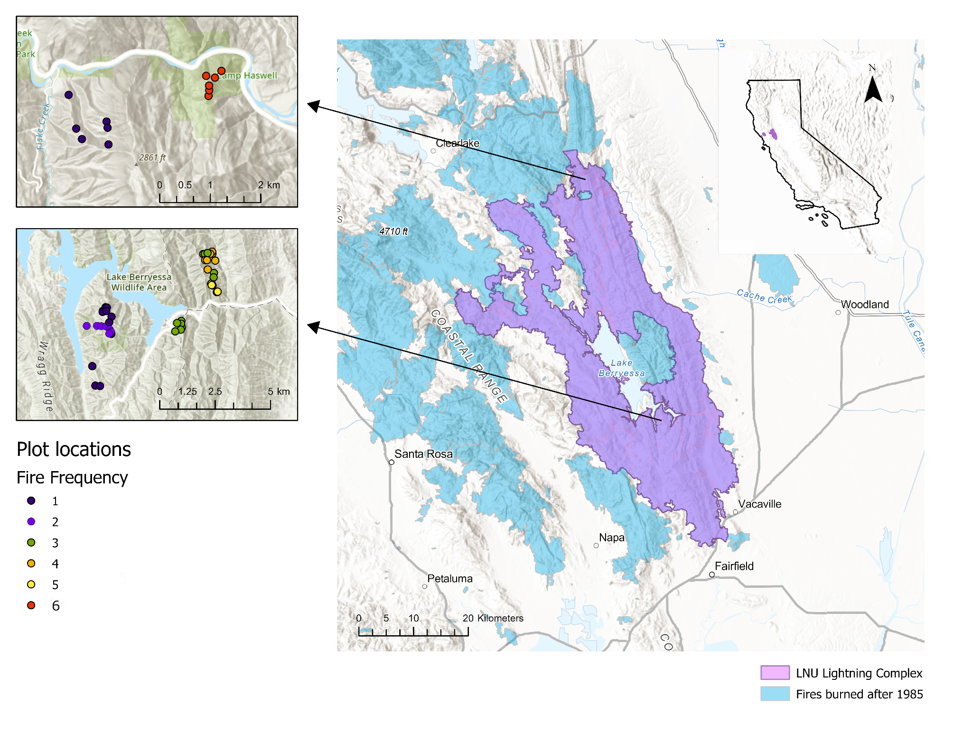

Fig. 1. Map of LNU Lightning complex (purple polygon) with locations of prior fires burned since 1985 (light blue polygons). The figures to the left show plot locations, which were distributed across a fire frequency gradient of 1 total burn (blue) up to 6 total burns in the past 30 years (red).

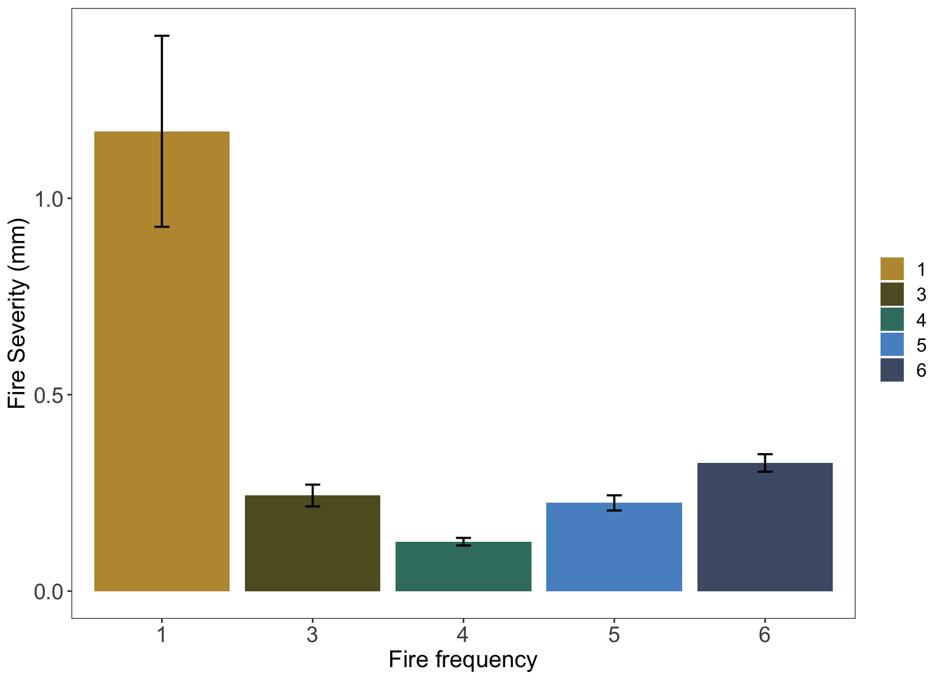

Fig 2: Measures of mean fire severity (mm) (± SE) decrease with increased fire frequency.

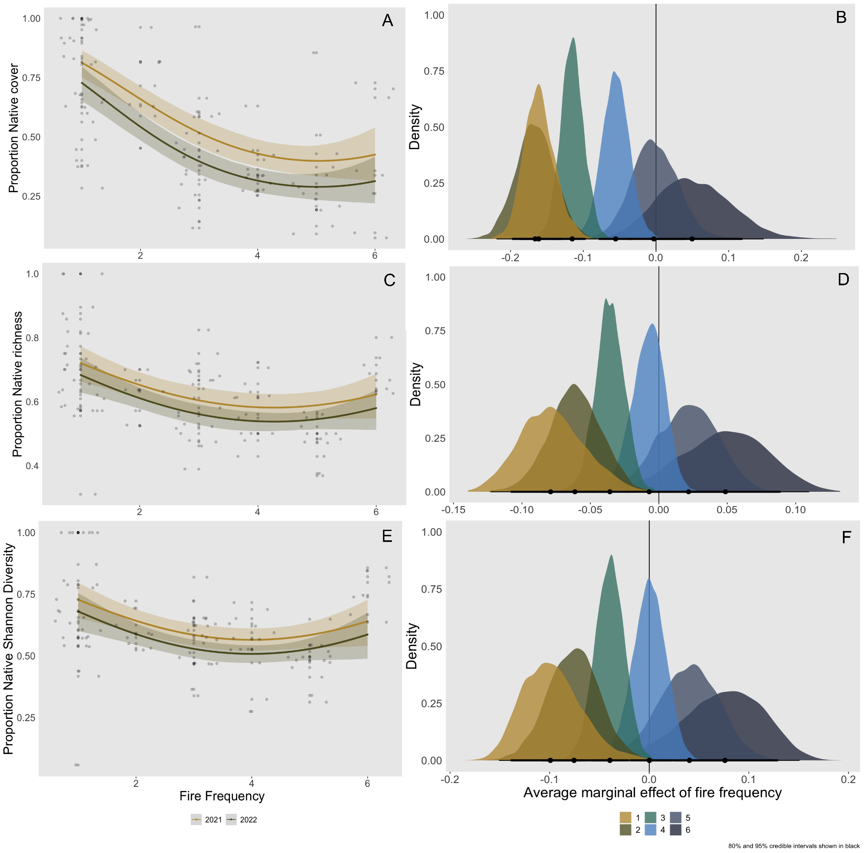

Fig 3: Proportion of native species cover (A), species richness (C), and Shannon diversity (E) at the plot level generally decline with increased fire frequency. Predicted values from the top-ranked Bayesian model with 95% credible intervals, as well as raw values (grey circles, n=103).

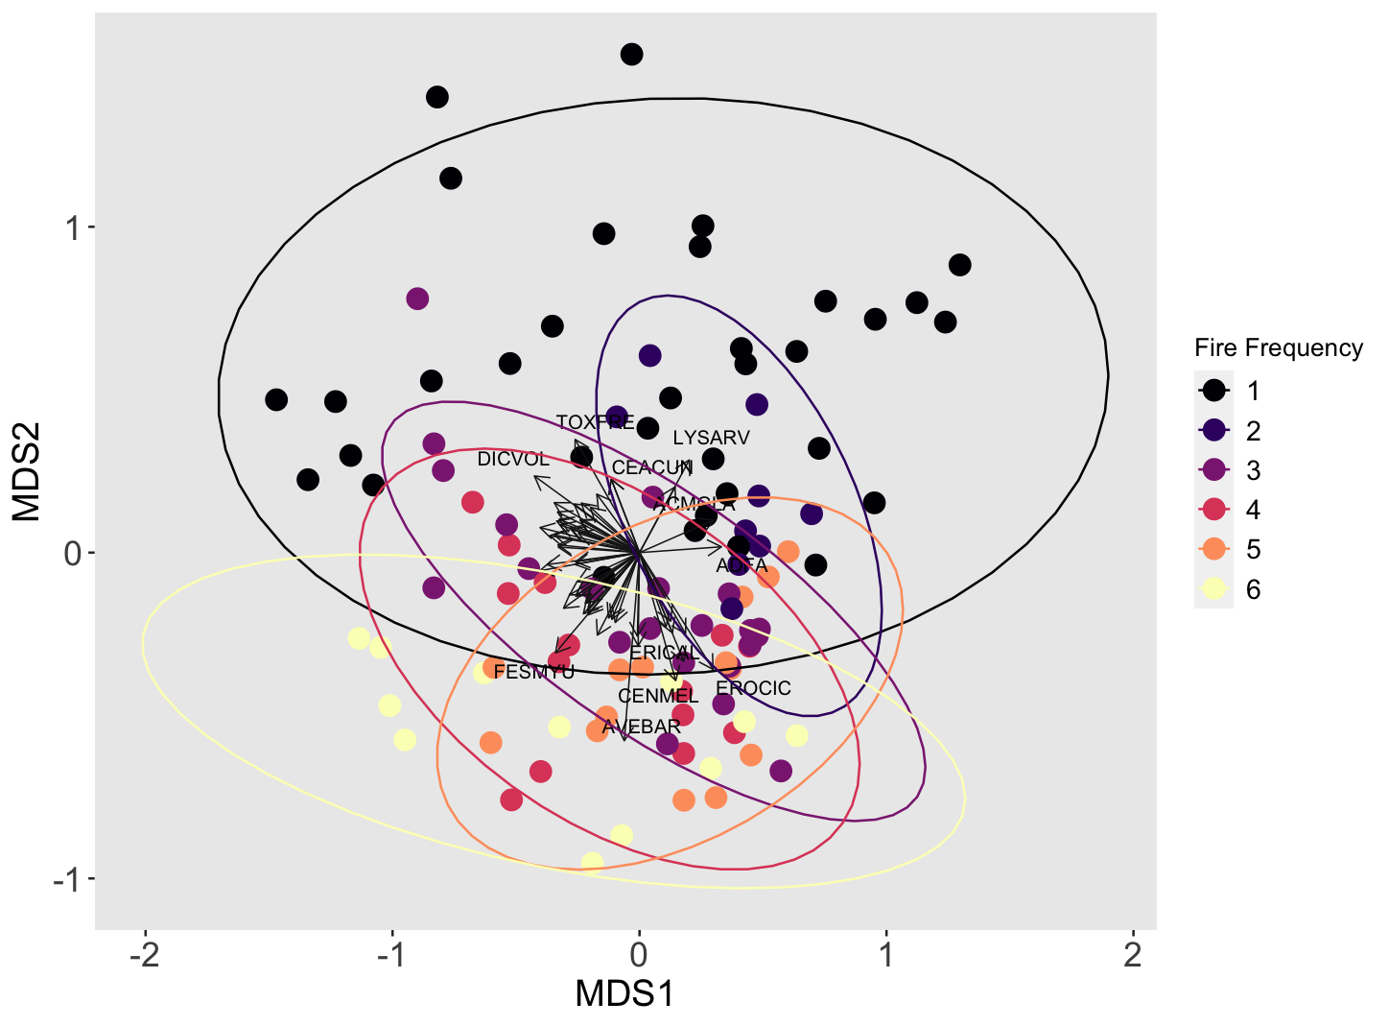

​​

Fig 4: Non-metric multidimensional scaling plot (NMDS) of Bray-Curtis dissimilarity matrix across fire frequency. Each point represents a survey point. Plots with higher fire recurrence (pink, orange, and yellow) are more clustered together, indicating that they have a more similar species composition than plots with lower fire recurrence (black, dark blue, purple). Labeling priority was given to more abundant and frequent species. Species codes: ACMGLA *Acmispon glaber,* ACMWRA *Acmispon wrangelianus,* ADFA *Adenostoma fasciculatum,* ASTGAM *Astragalus gambelianus,* AVEBAR *Avena barbata,* CEACUN *Ceanothus cuneatus,*CENMEL *Centaurea melitensis,* CLAUNG *Clarkia unguiculata,* DICVOL *Dichelostemma volubile,* ERICAL *Eriodictyon californicum,* EROCIC *Erodium cicutarium,* ESCCAE *Eschscholzia caespitosa,* FESMYU *Festuca myuros,* LYSARV *Lysimachia arvensis,* MELTOR *Melica torreyana,* NEMMEN *Nemophila menziesii,* STARIG *Stachys rigida,* TOXFRE *Toxicodendron fremontii,* TRIMIC *Trifolium microcephalum,* TRIMIC2 *Trifolum microdon.* Final stress of three dimensional solution = 0.166 after 24 iterations.

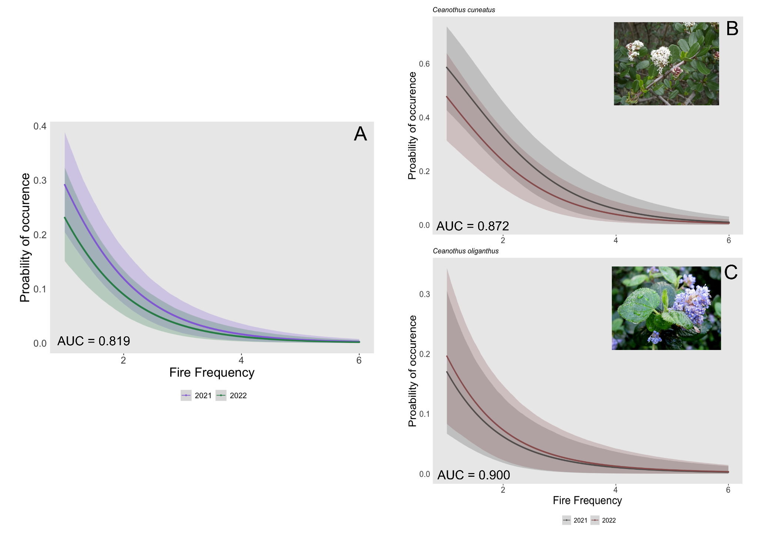

Fig 5: The probability of occurrence of a seedling from an obligate seeding shrub species (A), including *Ceanothus cuneatus* (B) and *Ceanothus oliganthus* (C), declined with increased fire frequency in both survey years (2021 & 2022). The probability of occurrence is the presence of at least one seedling in the 250m2 plot. Error bars show 95% CIs. The area under the receiver operating curve (AUC), a measure of model accuracy ranging from 0-1, noted in the bottom left.

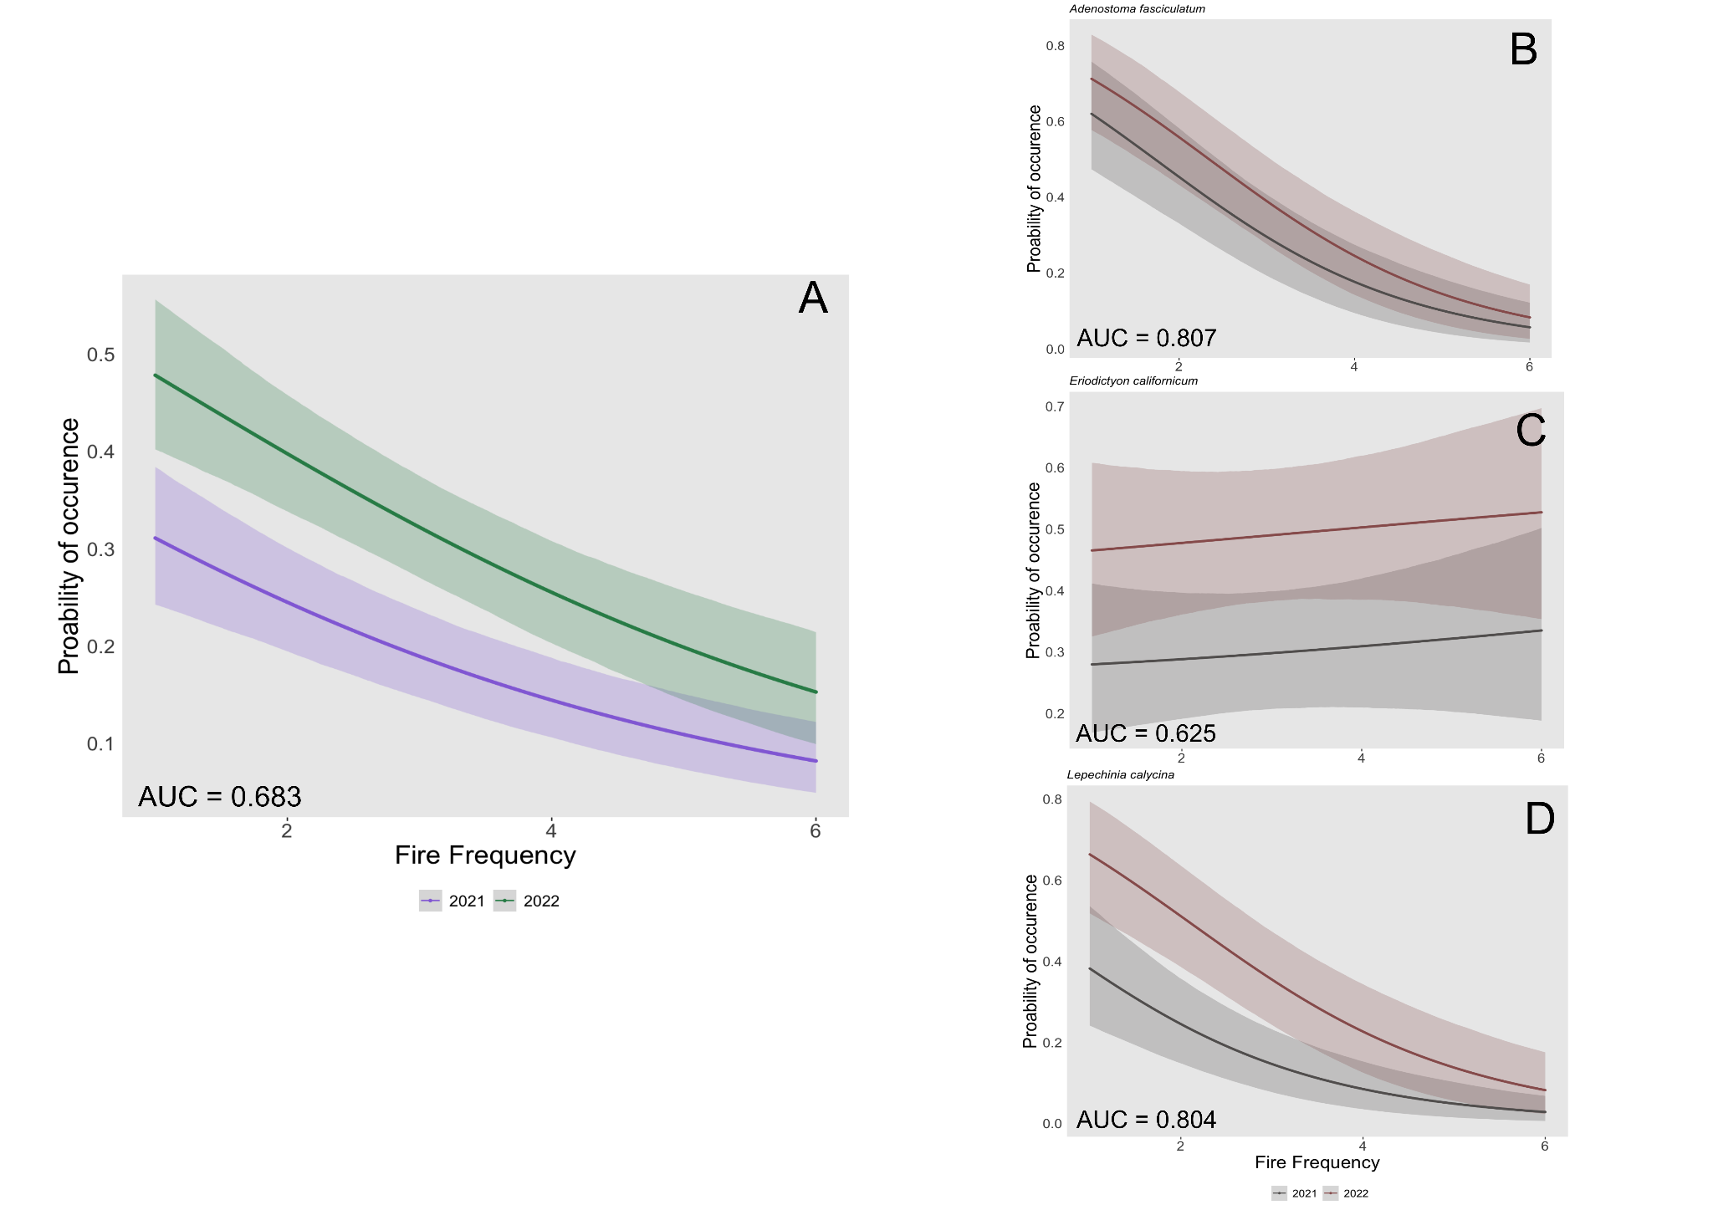

Fig 6: The probability of occurrence of a seedling from a facultative seedling shrub species (A) declined with increased fire frequency in both survey years (2021 & 2022). This relationship was species-dependent. Fire frequency had little change on the probability of occurrence of an *Eriodictyon californicum* seedling (C) but decreased the probability of occurrence for Adenostoma fasciculatum (B) and *Lepechinia calycina* (D) seedlings. The probability of occurrence is the presence of at least one seedling in the 250m2 plot. Error bars show 95% CIs. The area under the receiver operating curve (AUC), a measure of model accuracy ranging from 0-1, is noted in the bottom left.

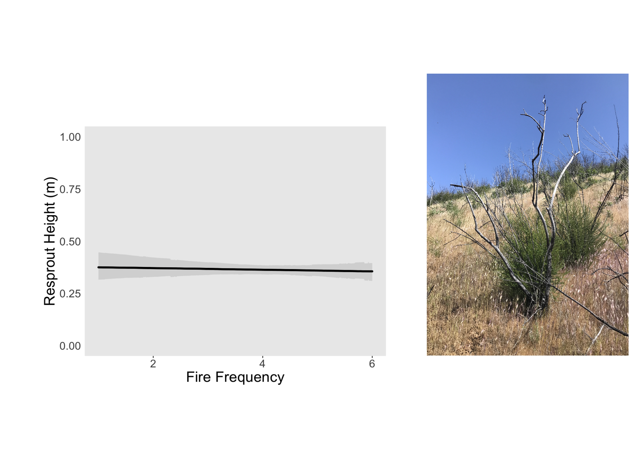

Fig. 7: Resprout height (m) of *Adenostoma fasciculatum* did not significantly change with increased fire frequency. Error bars show 95% CIs. Picture of *Adenostoma fasciculatum* individual that has experienced 3 short interval fires in the past 30 years.

Table 1: Description of all study sites included in the analysis.

|  |  |  |  |  |
| --- | --- | --- | --- | --- |
| Site | Jurisdiction | Fire History (since 1980) | Shortest interval between fire | Fire frequency (since 1985) |
| Bobcat Ranch | Audubon Canyon Ranch | 2020 (Hennessey), 2018 (County), 2016 (Cold), 2014 (Monticello), 2007 (Braye) | 2 | 3,4,5 |
| Quail Ridge | UC Natural Reserve | 2020 (Hennessey), 2005 (Pleasure) | 15 | 1,2 |
| Cold Canyon | UC Natural Reserve | 2020 (Hennessey), 2015 (Wragg),  Miller (1988) | 5 | 3 |
| Cache Creek | BLM | 2020 (Hennessey), 2012 (sixteen complex), 2004 (Rumsey), 2002 (Sixteen), 1999 (Rumsey), 1987 (Haswell) | 2 | 1,6 |

Table 2: Fire severity (mm) (± SE), which is positively related to the diameter of the measured stem termini, across the fire frequency gradient.

|  |  |  |  |  |  |
| --- | --- | --- | --- | --- | --- |
| Fire frequency | 1 | 3 | 4 | 5 | 6 |
| Mean fire severity (mm) | 1.17 ± 0.24 | 0.24 ± 0.03 | 0.13 ± 0.01 | 0.22 ± 0.02 | 0.32 ± 0.02 |
| Coefficient of variation in mean fire severity (%) | 88.1 | 40.6 | 21.1 | 28.9 | 18.3 |
| Maximum fire severity (mm) | 2.45 ± 0.48 | 0.49 ± 0.07 | 0.21 ± 0.03 | 0.40 ± 0.04 | 0.47 ± 0.02 |
| Coefficient of variation in max fire severity (%) | 83.3 | 50.0 | 54.4 | 19.7 | 12.0 |

# Supplemental Figures

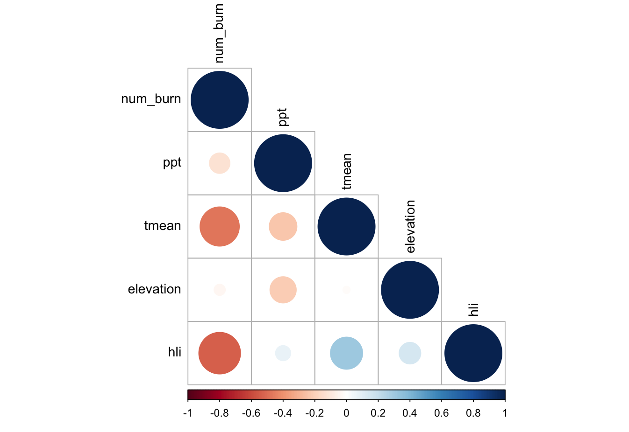

Supplemental Figure 1: Correlation plot of covariates included in this analysis. Spearman’s Rank Correlation Coefficients

Supplemental Table 1: Model summary for Bayesian model fit for the proportion of native species cover, proportion of native species richness, and proportion of native Shannon diversity.

|  |  |  |  |  |  |  |
| --- | --- | --- | --- | --- | --- | --- |
| **Native Species Cover** | Estimate | Est.Error | Lower 95% CI | Upper 95% CI | Rhat | Bulk_ESS |
| Intercept | 2.54 | 0.42 | 1.72 | 3.33 | 1.00 | 2335 |
| Num_burn | -1.17 | 0.26 | -1.67 | -0.67 | 1.00 | 2165 |
| Num_burn2 | 0.12 | 0.04 | 0.04 | 0.19 | 1.00 | 2200 |
| 2022 SurveyYear | -0.49 | 0.17 | -0.83 | -0.16 | 1.00 | 4612 |

|  |  |  |  |  |  |  |
| --- | --- | --- | --- | --- | --- | --- |
| **Native Species Richness** | Estimate | Est.Error | Lower 95% CI | Upper 95% CI | Rhat | Bulk_ESS |
| Intercept | 1.39 | 0.30 | 0.81 | 1.98 | 1.00 | 1596 |
| Num_burn | -0.50 | 0.18 | -0.86 | -0.15 | 1.00 | 1484 |
| Num_burn2 | 0.06 | 0.03 | 0.01 | 0.11 | 1.00 | 1439 |
| 2022 SurveyYear | -0.18 | 0.11 | -0.40 | 0.04 | 1.00 | 2856 |

|  |  |  |  |  |  |  |
| --- | --- | --- | --- | --- | --- | --- |
| **Native Shannon Diversity** | Estimate | Est.Error | Lower 95% CI | Upper 95% CI | Rhat | Bulk_ESS |
| Intercept | 1.56 | 0.41 | 0.77 | 2.40 | 1.00 | 2615 |
| Num_burn | -0.65 | 0.25 | -1.14 | -0.16 | 1.00 | 2523 |
| Num_burn2 | 0.08 | 0.04 | 0.01 | 0.15 | 1.00 | 2535 |
| 2022 SurveyYear | -0.23 | 0.13 | -0.49 | 0.02 | 1.00 | 6148 |